DIS-Pipes-Wolverine-TN

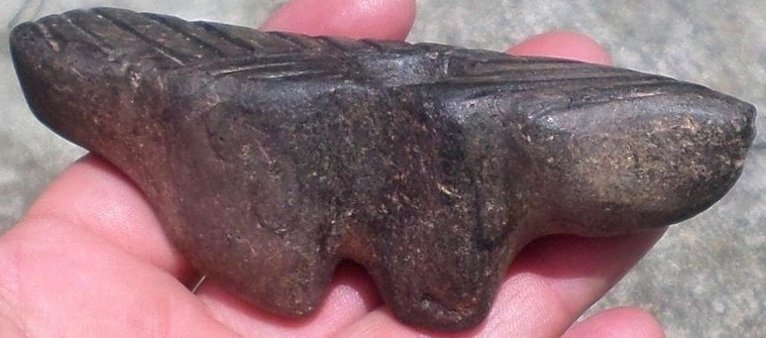

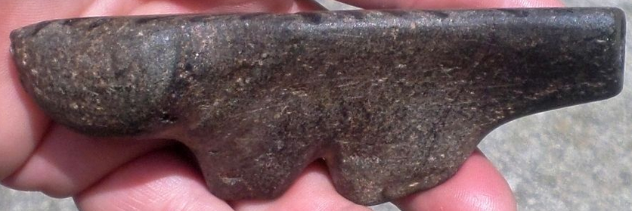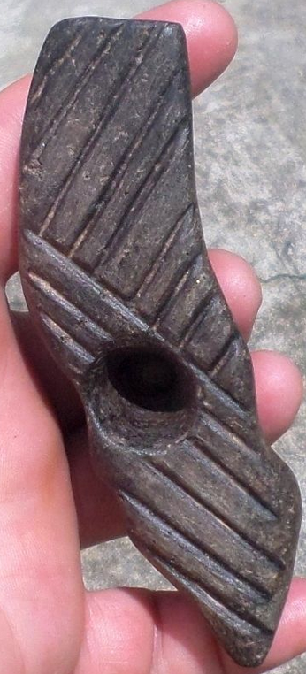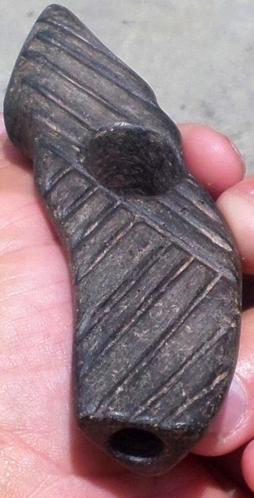

Black Steatite Wolverine Effigy Pipe

Black steatite wolverine effigy pipe that measures 4 5/8” x 1 5/8” x 1 3/8” wide. The top is very flat and has an etched design that covers the entire top. It is in very good condition. This piece is part of an old collection from Little Switzerland, North Carolina.

|  |  |  |
| --- | --- | --- |
| [SP1 Black Steatite Wolverine Effigy Pipe Indian Stone Artifact Native American](http://www.ebay.com/itm/181903906189?_trksid=p2057872.m2749.l2649&ssPageName=STRK%3AMEBIDX%3AIT)  ( 181903906189 )  Estimated delivery Wed, Oct 28  [Add note](javascript:;) | ITEM PRICE:  US $81.00 | **Item SP1 Black Steatite Wolverine Effigy Pipe Indian Stone Artifact Native American Orders 181903906189-0-0**[Leave feedback](http://feedback.ebay.com/ws/eBayISAPI.dll?LeaveFeedbackShow&useridto=tnreliccollector&transactID=0&item=181903906189&_trksid=p2057872.m2749.l2665)[Return this item](http://postorder.ebay.com/Return/ReturnViewSelectedItem?transactionId=0&itemId=181903906189&_trksid=p2057872.m2749.l3185)  [More actions](http://www.ebay.com/myb/PurchaseHistory) |